
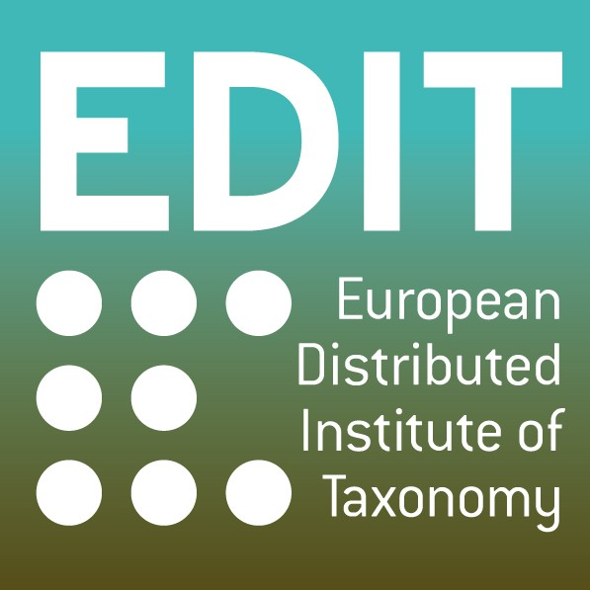

Project no. 018340

Project acronym: EDIT

Project title: Toward the European Distributed Institute of Taxonomy

Instrument: Network of Excellence

Thematic Priority: Sub-Priority 1.1.6.3: “Global Change and Ecosystems”

C5.46 Taxonomic exchange standard specification

Due date of deliverable: Month 19
Actual submission date: Month 19

Start date of project: 01/03/2006 Duration: 5 years

Organisation name of lead contractor for this deliverable: Partner number and Acronym of the Institution (as indicated in the Annex & - description of work)

Project co-funded by the European Commission within the Sixth Framework Programme (2002-2006)
Dissemination Level ( “X” in the relevant box)
PU | Public | X
PP | Restricted to other programme participants (including the Commission Services)
RE | Restricted to a group specified by the consortium (including the Commission Services)
CO | Confidential, only for members of the consortium (including the Commission Services)

As outlined in the report D5.45 (Identified and described suitable taxonomic tools), the cybertaxonomic platform architecture changed from a set of loosely coupled already existing taxonomic tools (geographic, descriptive, publishing, etc.) to a system based on a common data model (CDM) which uses the Unified Modelling Language (UML) and builds the ground for other applications interfacing with core CDM based data storages (fig. 1).

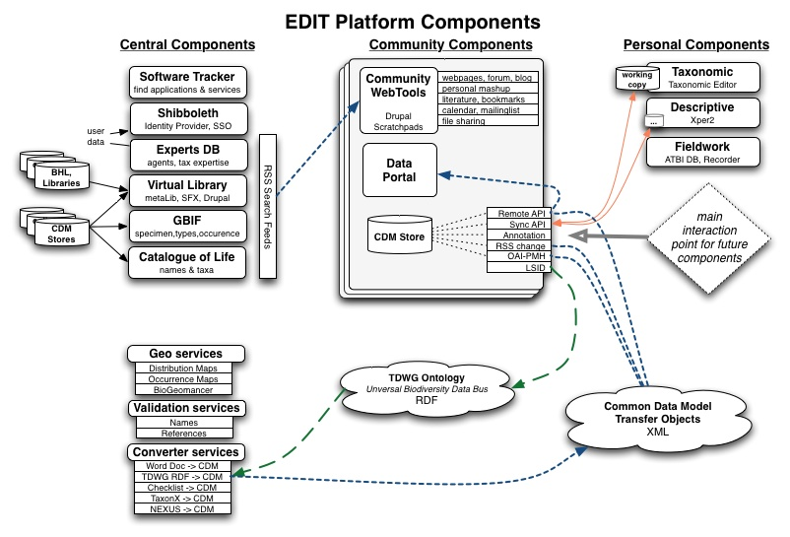
Fig. 1: EDIT cybertaxonomic platform

The CDM is comprehensive and covers names, taxa, observations, specimens, localities, agents, references as well as structured descriptions (fig. 2). Rather than inventing a new taxonomic model from scratch the CDM is built on existing standards in use such as the TDWG ontology, BibTex, SDD, ABCD, DarwinCore, and the Berlin taxonomic information model. With this, maximum compliance to existing applications and services is achieved. The model is developed in an open process using an EDIT email list (https://webmail.mnhn.fr/wws/arc/cdm-edit) monitoring all changes and additions to the model and offering the opportunity to discuss critical decisions. The discussion process is accompanied by a detailed web-documentation of the present state of the model (http://dev.e-taxonomy.eu/trac/wiki/CommonDataModel#UMLdocumentation).

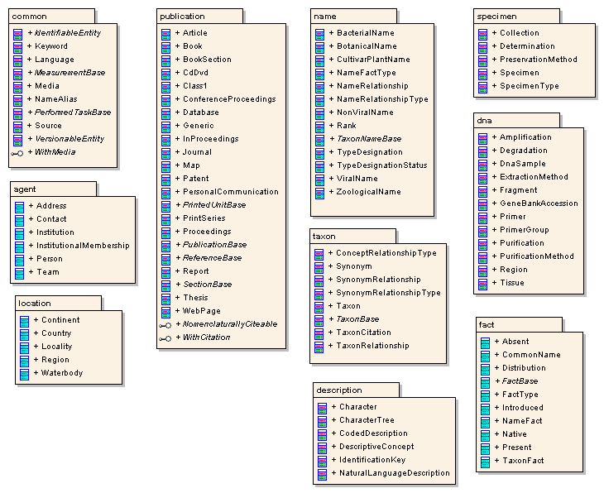

Fig. 2: Present state of the common data model object packages

The model specification, being integrated and containing implementation constraints such as cardinalities, will widely replace a data interchange specification as applications will directly use CDM store interfaces (e.g. APIs) rather than communicating data files based on an information standard. However, CDM stores will be able to either produce data compliant to existing standards (e.g. TCS) directly or services will be implemented to transform CDM data (e.g. XML serializations) into a wide spectrum of other formats to ensure that EDIT cybertaxonomic platform integrates with emerging world-wide biodiversity data infrastructure.

